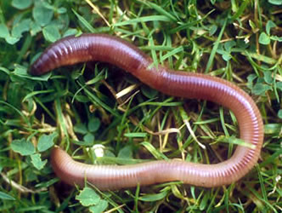  7-35 cm  Earthworms  Eat: Dead organic matter,  fungi, bacteria  Eaten by: American robins | 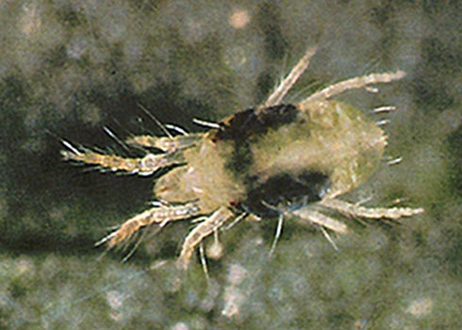  0.5-1 mm  Mites  Eat: Nematodes, fungi  Eaten by: Beetles | 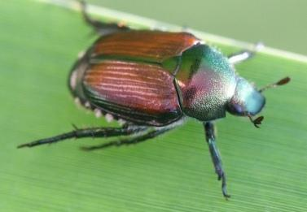  1-3 mm  Beetles  Eat: Mites  Eaten by: American  robins
Fungi  Consume: Dead organic  matter  Eaten by: Earthworms,  mites, nematodes, | 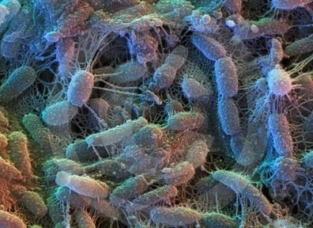  2-6 µm  Bacteria  Consume: Dead organic  matter  Eaten by: Protista,  nematodes,  earthworms | 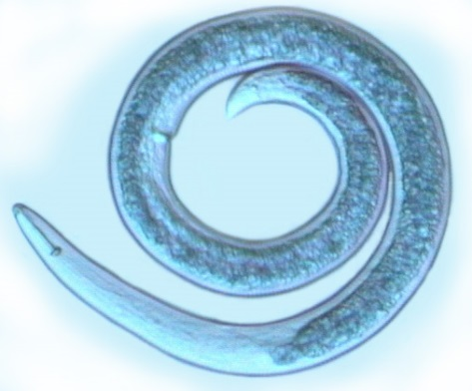  0.1-2.5 mm  Nematodes  Eat: Protista, fungi,  bacteria  Eaten by: Mites

<80-400 cm  Willows  Eaten by: Elk | Grasses (including seeds)  Eaten by: Elk, deer  mice, yellow-  bellied marmots | Dead Organic Matter  Consumed by: Bacteria,  fungi, earthworms
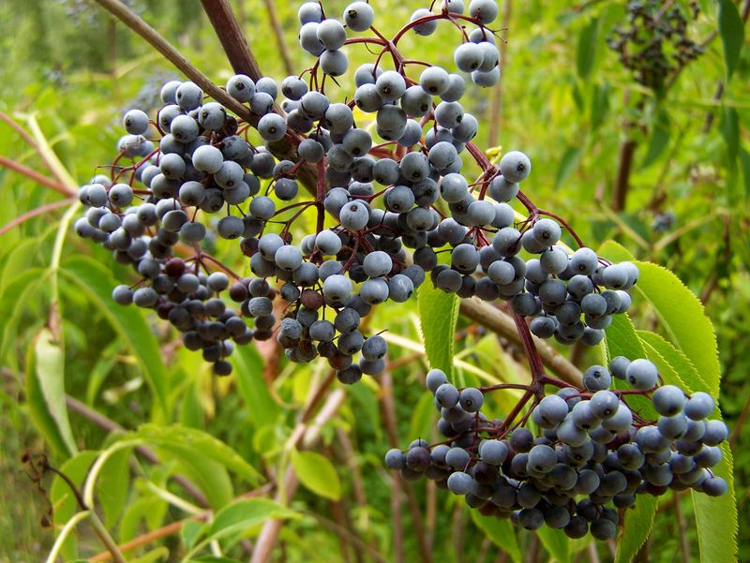  Other flowering plants  (including berries)  Eaten by: American  robins, deer mice,  elk, grizzly bears,  yellow-bellied  marmots | 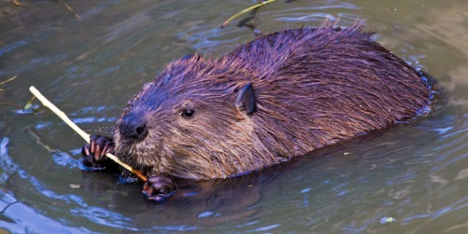58-99 cm (length, excluding tail)  Beavers  Eat: Willows  Eaten by: Gray wolves | 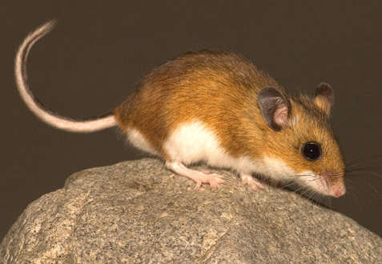  8-10 cm (length, excluding tail)  Deer Mice  Eat: Grasses; other  flowering plants  Eaten by: Coyotes

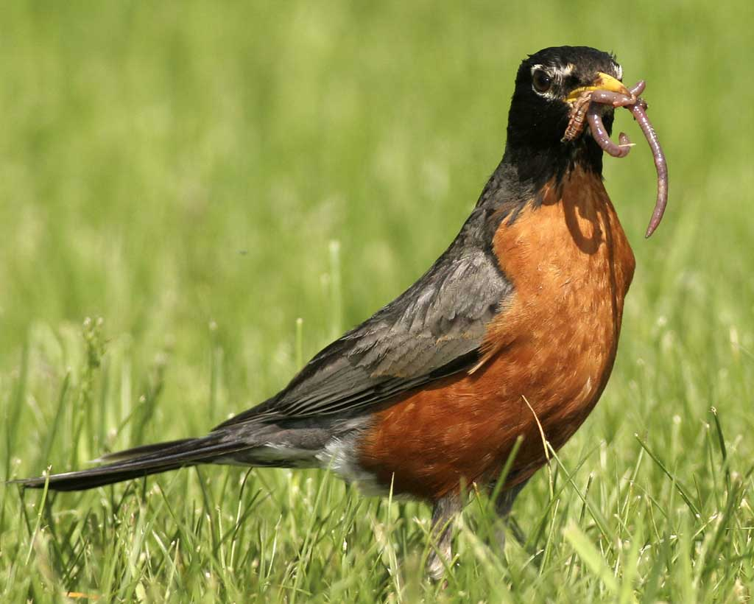  23-28 cm  American Robins  Eat: Earthworms, beetles,  other flowering plants  Eaten by: Snakes and  birds of prey (not  included in this food web) | 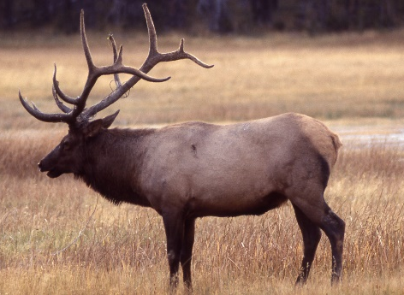  2.1-2.4 m  Elk  Eat: Grasses, willows,  other flowering  plants  Eaten by: Gray wolves,  grizzly bears | 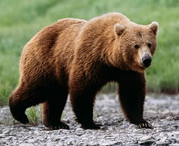  1.8-3.3 m  Grizzly Bears  Eat: Other flowering  plants, elk
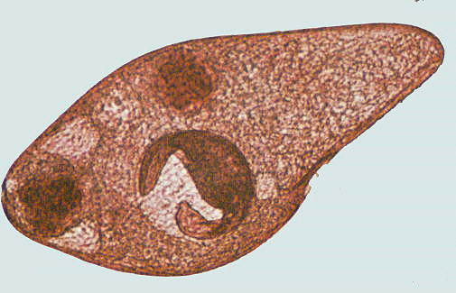  <1 mm  Protista  Eat: Bacteria  Eaten by: Nematodes | 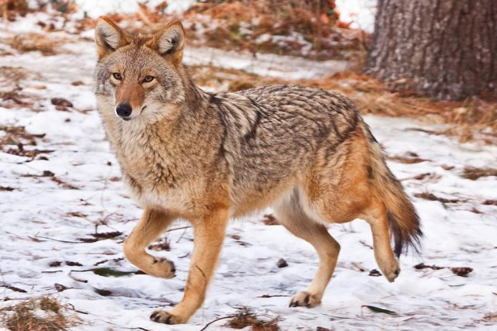  1-1.4 m  Coyotes  Eat: deer mice, yellow-  bellied marmots  Eaten by: Gray wolves | 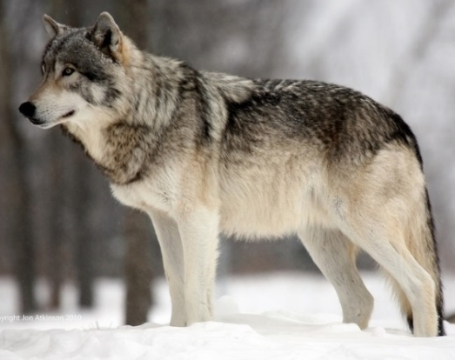  1.4-2 m  Gray Wolves  Eat: Elk, coyotes

